***Name=Aditya Anal***

***Profile=Data Enginner***

***GIT Commands Tutorials***

**Git:** There are many different ways to use Git. Git supports many command-line tools and graphical user interfaces. The Git command line is the only place where you can run all the Git commands.

**1.git version:** When you run this command it will display your current Git version.

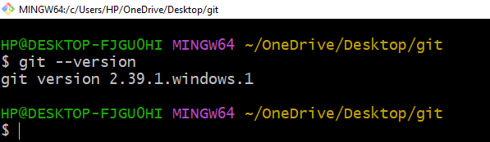

**2.Git config command:** This command configures the user. The Git config command is the first and necessary command used on the Git command line. This command sets the author name and email address to be used with your commits. Git config is also used in other scenarios.

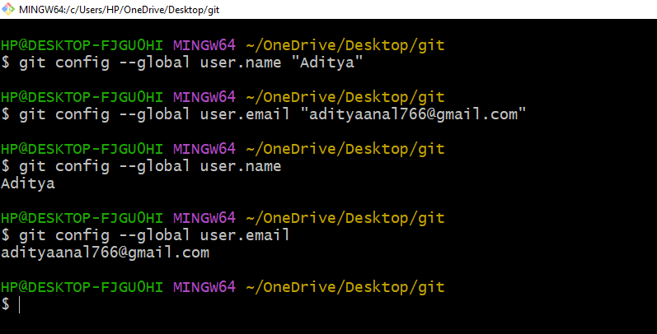

### 3.Git Init command: This command is used to create a local repository.

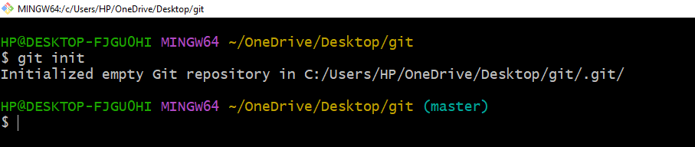

**4.Git Status command:**  to give the currents status of file.

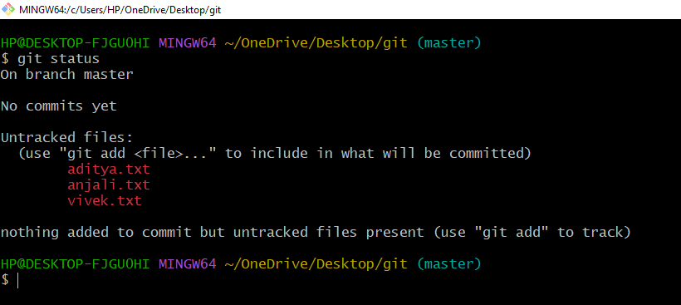

### 4.Git add command: This command is used to add one or more files to staging (Index) area.

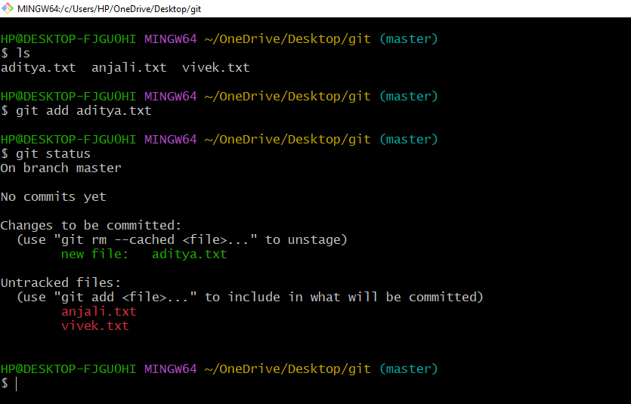

### 5.Git commit command: Commit command is used in two scenarios. They are as follows.

**Git commit –m:** This command changes the head. It records or snapshots the file permanently in the version history with a message.

**Git commit –a:** This command commits any files added in the repository with git add and also commits any files you've changed since then.

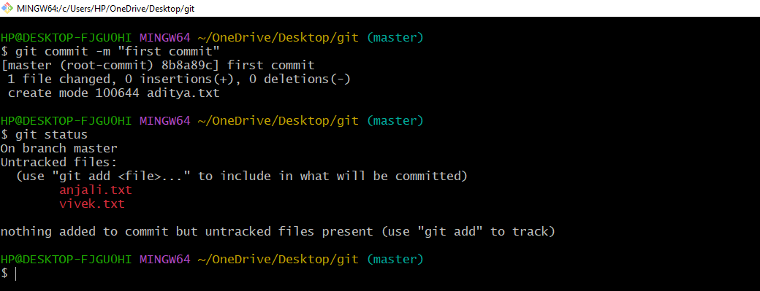

**6.Git All command:** to select all file and add .

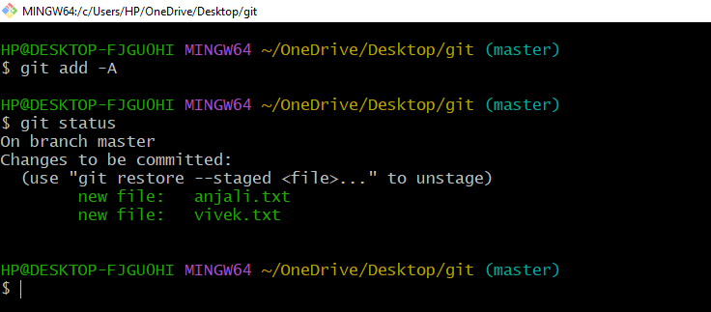

**7.For modified show**

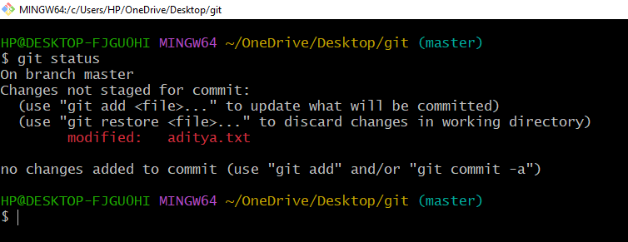

**8.Checkout :** to modified the change.

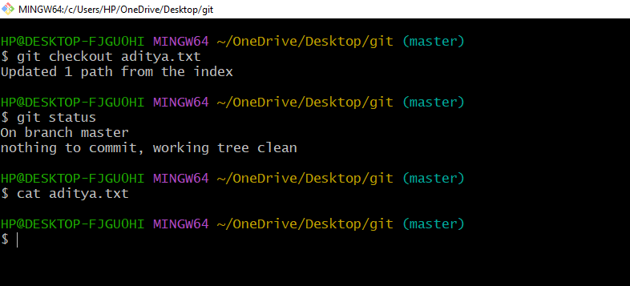

**9.Git diff:** to see the change menas compare to file files after modified the file.

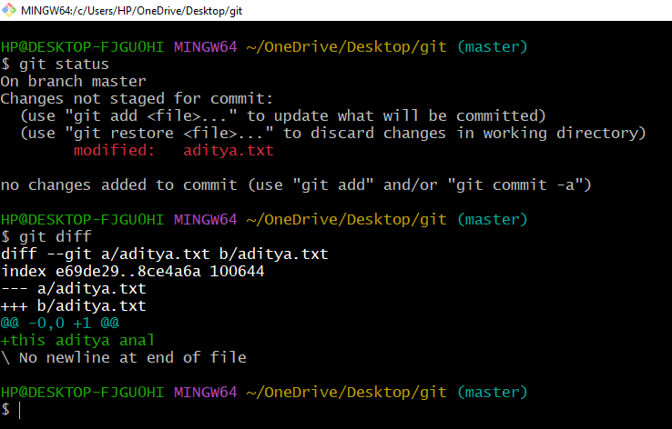

**10.Git log:** This command is used to check the commit history.

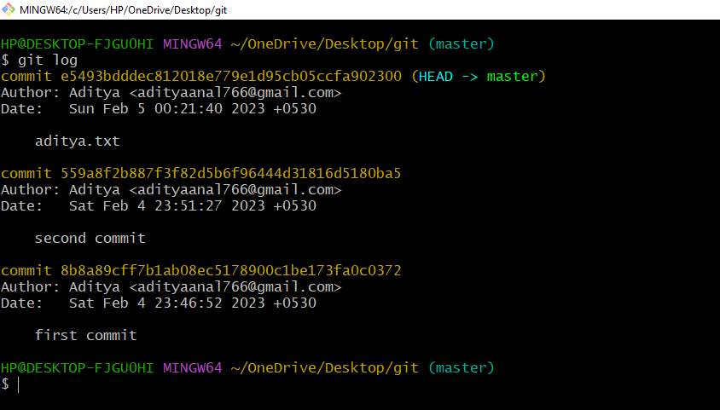

**11.Git log – stat:** to check the all modified file history withn time and date.

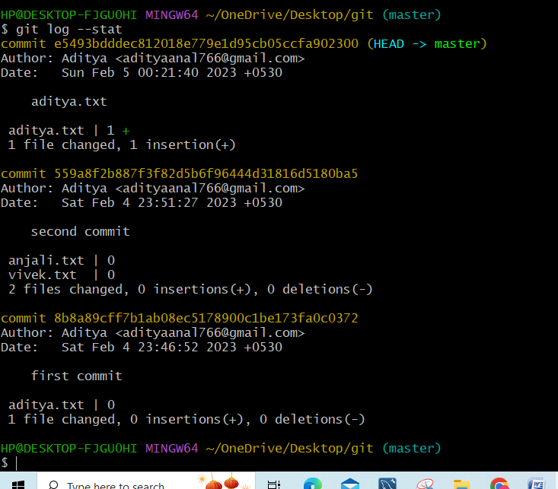

**12.Git rm –cached file.txt:**to remove the file in staged area.

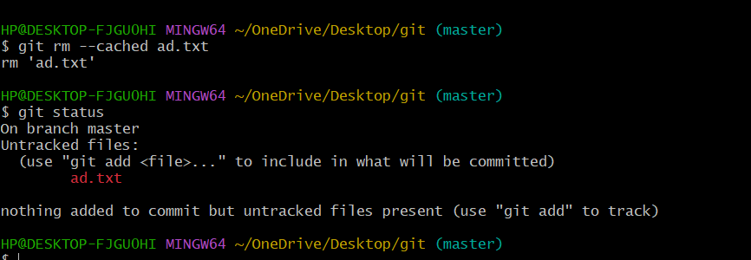

**13.Git rm –f file.txt:**remove the file means delete the file parment.

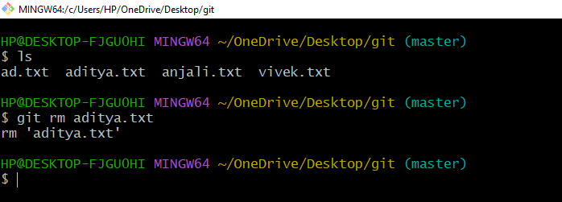

**14.git branch –list:**  to give list of branch .

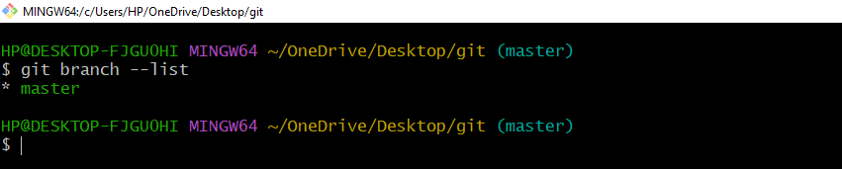

**15. git branch (name):** to create the new branch .

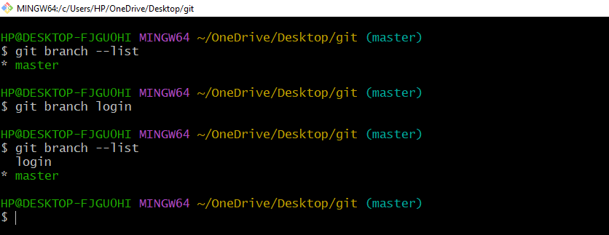

**16.git checkout :**  to change the branch( master to login).

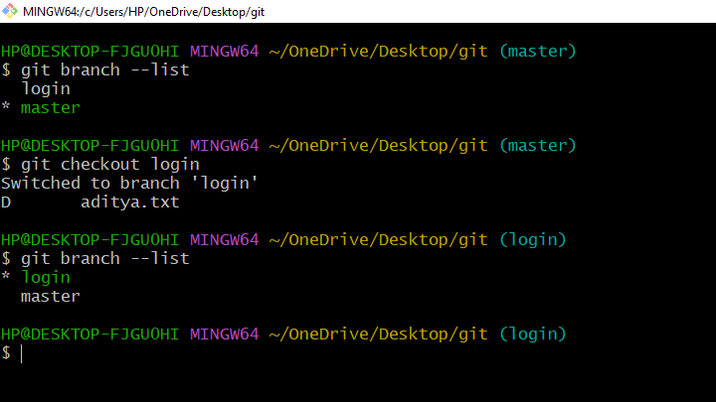

### 17.Git push Command: It is used to upload local repository content to a remote repository. Pushing is an act of transfer commits from your local repository to a remote repo.

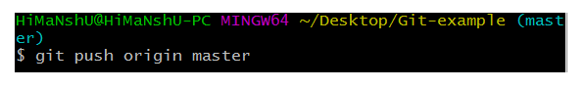

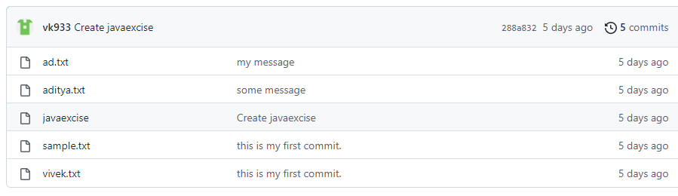

### 18) Git pull command: Pull command is used to receive data from GitHub. It fetches and merges changes on the remote server to your working directory.

